LINUX USER MANAGEMENT

1)  Create user "nikhil" with home directory set as "/home/nikhil"  
       a) nikhil user should have "/bin/sh" shell for his environment

COMMANDS USED

root@ip-172-31-30-52:/home/ubuntu# sudo useradd -m nikhil

root@ip-172-31-30-52:/home/ubuntu# ls /home/

root@ip-172-31-30-52:/home/ubuntu# sudo su damini

$ ls -l /bin/ | grep sh

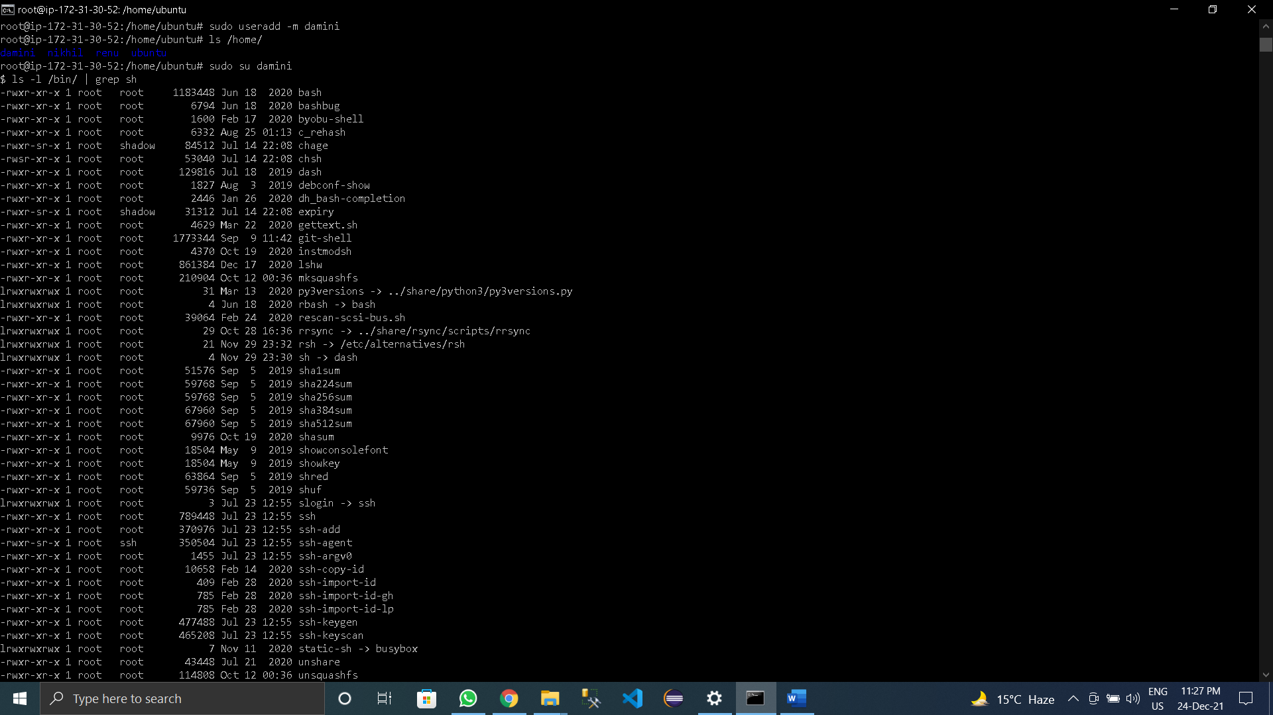

  b) His password should expire in 9 days and 2 days before password expiry, he should get warning. User account must expire in 1 month from creation date

**COMMANDS USED:-**

root@ip-172-31-30-52:/home/ubuntu# passwd -x9 nikhil

root@ip-172-31-30-52:/home/ubuntu# passwd -w2 nikhil

root@ip-172-31-30-52:/home/ubuntu# sudo chage -E 2021-12-24 nikhil

root@ip-172-31-30-52:/home/ubuntu# chage -l nikhil

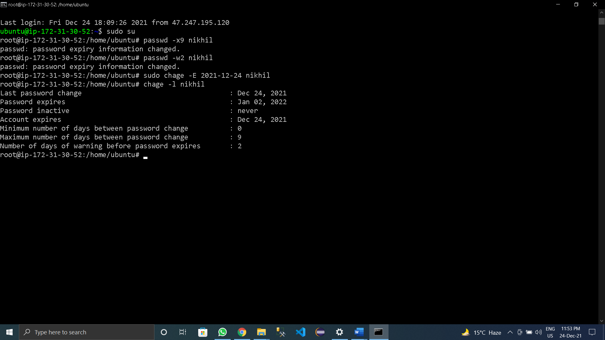

  c) Give him root privileges to start/stop cron daemon.

**COMMANDS USED:-**

root@ip-172-31-30-52:/# grep root /etc/passwd

root@ip-172-31-30-52:/# grep nikhil /etc/passwd

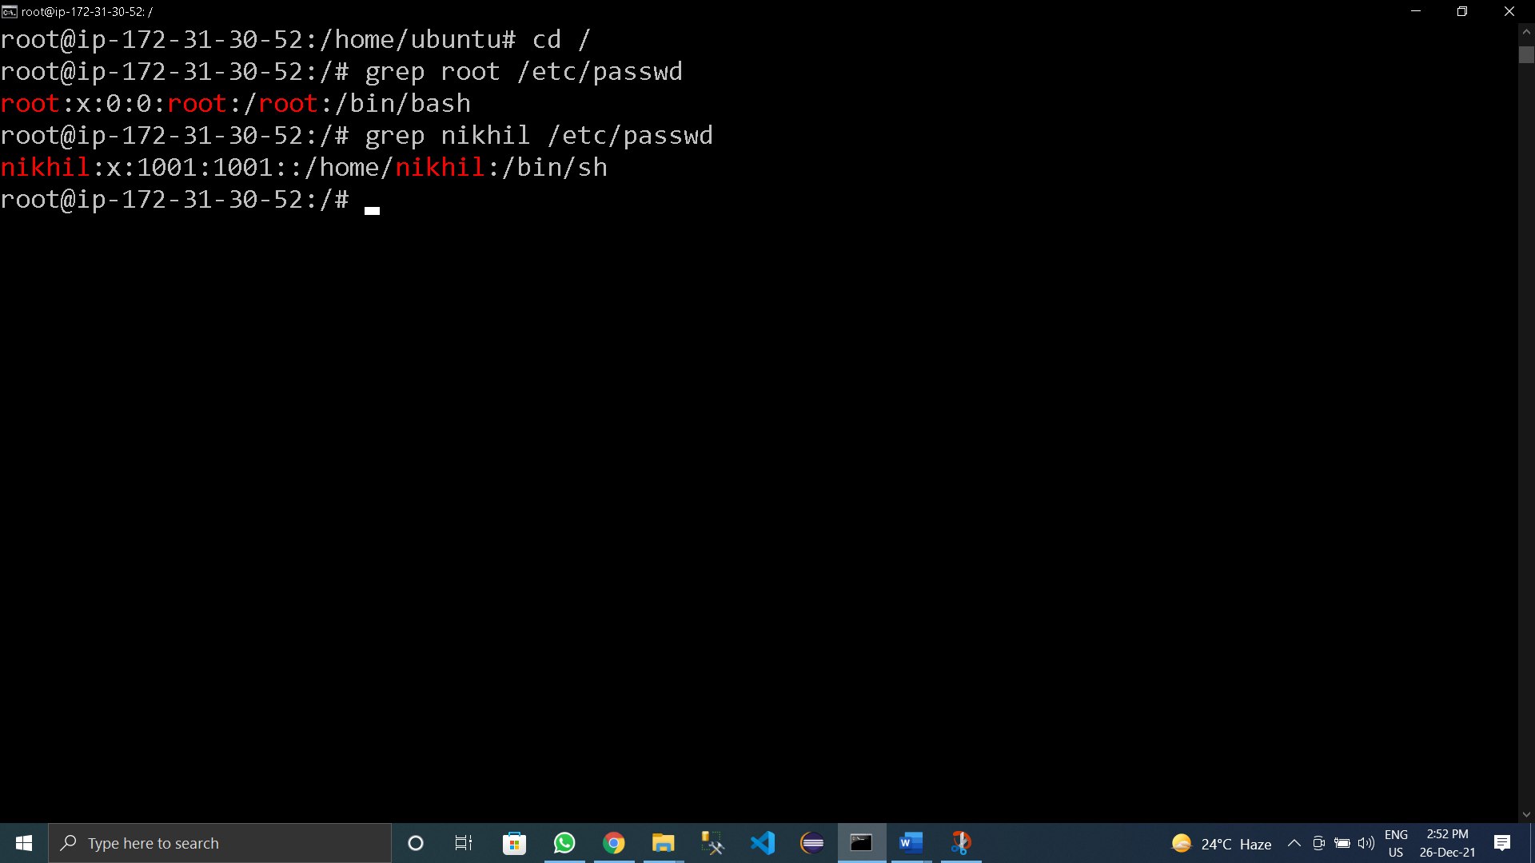

2) Inside folder "/" , create new home directory as "nikhil" (/nikhil) and setup this folder as a home directory for user "nikhil"

root@ip-172-31-30-52:/# mkdir nikhil

root@ip-172-31-30-52:/# ls

root@ip-172-31-30-52:/# usermod -d /nikhil/ nikhil

root@ip-172-31-30-52:/# sudo su nikhil

$ pwd

/

$ cd ~

$ pwd

/nikhil

